UNIVERSITY OF SCIENCE AND TECHNOLOGY OF HANOI
DEPARTMENT OF INFORMATION AND COMMUNICATION TECHNOLOGY



BACHELOR THESIS

By
<Student’s name>

Title:
<AAA>

External Supervisor: Prof. Dr. NGUYỄN VĂN A
Internal Supervisor: Prof. Dr. NGUYỄN VĂN B

Hanoi, <Month – yyyy>

Hanoi, September 2013

HàNội, Sept. 2012

To whom it may concern,

I, …………………….……………………………… (supervisor’s name), certify that the thesis/ internship report of Mr/Ms. …………………………………………(student’s name) is qualified to be presented in the Internship Jury 2025-2026.

Hanoi, <date>
Supervisor’s signature

Table of Contents
ACKNOWLEDGEMENTS 0
LIST OF ABBREVIATIONS 1
LIST OF TABLES 2
LIST OF FIGURES 3
ABSTRACT 4
I/ INTRODUCTION 1
II/ OBJECTIVES 2
III/ MATERIALS AND METHODS 3
IV/ RESULTS AND DISCUSSION 4
V/ CONCLUSION & PERSPECTIVE 7
REFERENCES 8
APPENDICES 9

ACKNOWLEDGEMENTS
Example of acknowledgements
“I would like to express my gratitude to all those who gave me possibility to complete this thesis in specific as well as academic supporting in general that I received during the time of my studying at the University of Science and Technology of Hanoi.
Foremost, I would like to send my honest thanks to my supervisor...”

LIST OF ABBREVIATIONS
Example of list of abbreviations

BP | Biotechnology- Pharmacology
CMOS | Complementary Metal-Oxide-Semiconductor
CMRR | Common-Mode Rejection Ratio
ICT | Information and Communication Technology
NMC | Nested Miller Compensation
GB | Gain Bandwidth
USTH | University of Science and Technology of Hanoi

LIST OF TABLES
Example of list of tables
Table 1: Topographic parameters measured for the 15 gully heads in 2009 …………….9
Table 2: Simulation setup .................................................................................................10

LIST OF FIGURES
Example of list of figures
Figure 1: Hexagon group-based deployment mode ..........................................................10
Figure 2: Smoothed tree density and tree canopy area in the catchment from 1945 to 2009………………………………………………………………………………………11

ABSTRACT

(No more than 250 words, in English + 6 key words)

Example of abstract

We present a fully-integrated compact (1.1 mm2) target device for Near Field Communication (NFC). The design of the key analog part of the tag IC is presented, which includes a robust demodulator for 10% ASK envelope detection, a high quality random number generator, an adaptive RF limiter, and a low power clock generator. A 128 bit advanced encryption standard (AES) with new cyclic key generation is used for secure data encryption and decryption. An on-chip 4Kb EEPROM is used to support the AES operation. The tag chip is fabricated in a 1-poly 6-metal low-power (LP) 0.18 μm CMOS process with a CoSi2-Schottky diode and EEPROM process.
Key words: Near Field Communication, ASK, AES, low power, Schottky diode, EEPROM process.

I/ INTRODUCTION
(Global context, literature review, main questions and objectives including the presentation of the problem with the scientific background, 2-3 pages)

II/ OBJECTIVES
Scientific objective of the internship: submit your goal and summarize the strategy in 2-3 concise sentences

III/ MATERIALS AND METHODS
(Presenting in this section the materials and the methods you have used. Methods have to be presented not in the form of a bench protocol but rather in a style suitable for publication (a paragraph of complete sentences) and include all information necessary for a third person to reproduce your experiments (in detail but condensed))

IV/ RESULTS AND DISCUSSION
- Results: Description of the student's own research, procedures and results. Interpretation of the student's results; conclusions and review of the results comparison with other research; critical assessment of the student's own work; limitation of the study).
- Discussion: in this section you have to do a critical analysis and discuss the results you obtained in regards to the data already available in the scientific literature. In case of failure you have to analyze the reasons and propose an alternative strategy. In case of success you have to state the essential new information your work has given to solve the scientific problem and about the immediate perspective that it opens.
Example of table to present your results (always choose between table or figure)
Table 1: Topographic parameters measured for the 15 gully heads in 2009
GULLY NUMBER | Drain.A  (m²) | DAslope  (%) | LHS  (%) | SPI | GL  (m) | GHA  (m²) | GVol  (m³) | RL  (m y⁻¹) | Retreat.A  (m² y⁻¹) | V  (m³ y⁻¹)
1 | 41258 | 28.4 | 17.3 | 3.78 | 120 | 4844 | 7673 | 0.67 | 68.6 | 218
2 | 85597 | 29.4 | 30.1 | 5.39 | 225 | 11695 | 28096 | 0.33 | 202.0 | 727
3 | 8490 | 12.1 | 10.2 | 3.05 | 98 | 2258 | 2090 | 1.33 | 56.3 | 150
4 | 105150 | 30.9 | 12.2 | 3.83 | 218 | 8101 | 53650 | 0.33 | 56.6 | 358
5 | 26467 | 18.8 | 6.4 | 2.26 | 143 | 4175 | 22030 | 0.33 | 14.6 | 69
6 | 13054 | 18.8 | 12.9 | 3.56 | 68 | 875 | 1998 | 0.33 | 4.0 | 11
7 | 17412 | 26.7 | 13.9 | 3.82 | 69 | 809 | 1459 | 0.67 | 19.0 | 64
8 | 14350 | 17.7 | 8.8 | 4.78 | 71 | 1393 | 1875 | 1.33 | 38.6 | 122
9 | 103776 | 24.2 | 10.0 | 1.89 | 240 | 12008 | 79928 | 1.33 | 163.6 | 1303
10 | 3701 | 12.9 | 8.7 | 1.69 | 65 | 1795 | 4235 | 0.67 | 52.6 | 266
11 | 2790 | 9.1 | 5.4 | 0.79 | 57 | 555 | 423 | 0.33 | 15.0 | 17
12 | 57941 | 30.4 | 9.1 | 4.14 | 63 | 1196 | 4429 | 1.00 | 33.0 | 157
13 | 38924 | 28.2 | 7.1 | 3.17 | 132 | 3585 | 23642 | 1.67 | 113.0 | 897
14 | 9240 | 36.4 | 15.7 | 3.30 | 73 | 1292 | 2995 | 0.67 | 43.6 | 156
15 | 3039 | 10.5 | 12.2 | 1.87 | 64 | 911 | 1922 | 0.67 | 35.0 | 123
mean | 35412 | 22.3 | 12.0 | 3.20 | 113 | 3699 | 15763 | 0.77 | 61.0 | 309
SD | 36336 | 8.6 | 6.0 | 1.05 | 64 | 3881 | 23140 | 0.44 | 56.5 | 374
Table 2: Simulation setup

Symbol | Value | Description
N | 10,000 | Number of nodes in the network
S | 1000x1000(m²) | Network deployment area
r | 40m | The communication range
M | 200 keys | The memory size of nodes for storing key materials.
Ϭ | 50m | The standard deviation in Gaussian distribution.

Example of figure to present your results:

Figure 1: Hexagon group-based deployment model

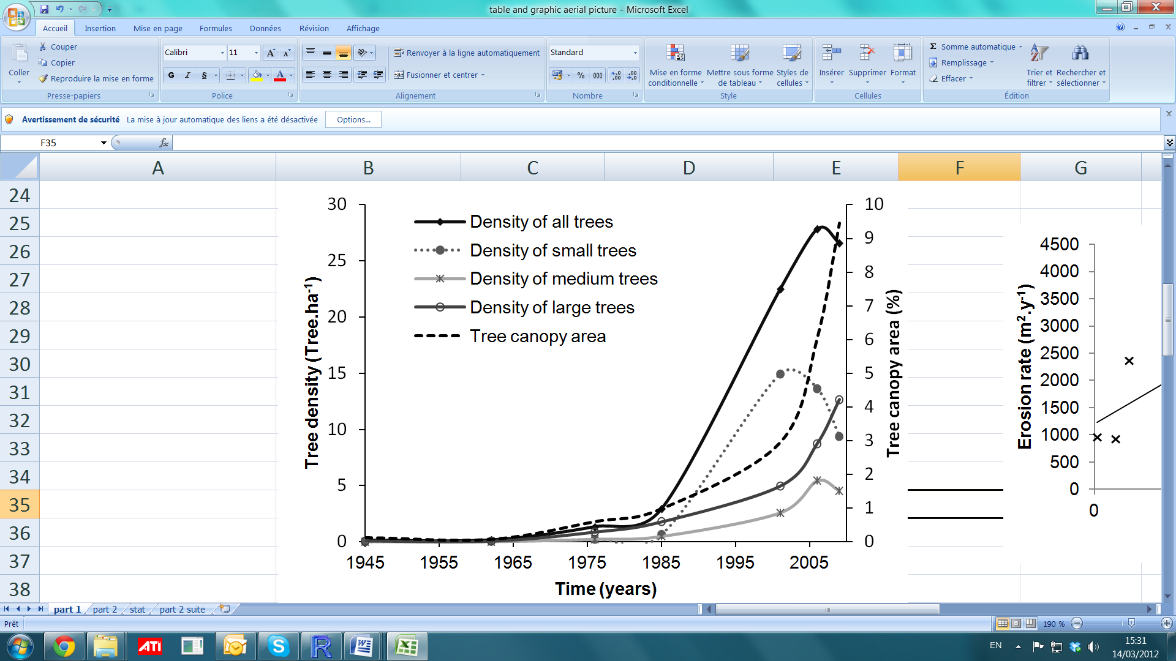
Figure 2: Smoothed tree density and tree canopy area in the catchment from 1945 to 2009
Smoothed tree density and tree canopy area in the catchment from 1945 to 2009. Small trees (canopy area < 1 m2), medium-sized trees (1 m2< canopy area< 15 m2), large trees (canopy area> 15 m2).

Note: Never start your result section with a Fig or Table only. An introduction paragraph should be added.

V/ CONCLUSION & PERSPECTIVE
The conclusion recapitulates the main achievements of your work and the main perspectives it opens.

REFERENCES
Please ensure that every reference cited in the text is also present in the references list (and vice versa);
References style:
- Text: Indicate references by number(s) in square brackets in line with the text. The actual authors can be referred to, but the reference number(s) must always be given.
- Example: '..... as demonstrated [3,6]. Barnaby and Jones [8] obtained a different result ....'.
- References list: Number the references (numbers in square brackets) in the list in the order in which they appear in the text.
Reference formatting: author(s) name(s), journal title/ book title, chapter title/article title, year of publication, volume number/book chapter (issue), and the article number or pagination must be present. Use of DOI is highly encouraged.
For articles/books with more than 10 authors, list the first 10 followed by “et al.

- Examples:
- Reference to a journal publication:
[1] J. van der Geer, J.A.J. Hanraads, R.A. Lupton, The art of writing a scientific article, J. Sci. Commun. 2010, 163 (2), pp. 51–59. https://doi.org/10.1016/j.Sc.2010.00372.
Reference to a journal publication with an article number:
[2] Van der Geer, J., Hanraads, J.A.J., Lupton, R.A., 2018. The art of writing a scientific article. Heliyon. 19, e00205. https://doi.org/10.1016/j.heliyon.2018.e00205.
- Reference to a book:
[3] W. Strunk Jr., E.B. White, The Elements of Style, fourth ed., Longman, New York, 2000.
Reference to a chapter in an edited book:
[4] G.R. Mettam, L.B. Adams, How to prepare an electronic version of your article, in: B.S. Jones, R.Z. Smith (Eds.), Introduction to the Electronic Age, E-Publishing Inc., New York, 2009, pp. 281–304.
- Reference to a website:
[5] Cancer Research UK, Cancer statistics reports for the UK. http://www.cancerresearchuk.org/aboutcancer/statistics/cancerstatsreport/ , 2003 (accessed 13 March 2003).
- Reference to a dataset:
[dataset] [6] M. Oguro, S. Imahiro, S. Saito, T. Nakashizuka, Mortality data for Japanese oak wilt disease and surrounding forest compositions, Mendeley Data, v1, 2015. https://doi.org/10.17632/xwj98nb39r.1.

APPENDICES
APPENDIX 1

APPENDIX 2

